ACTIVITY : 7 : PERFORMANCE TESTING :

● The amount of data that is rendered to a database depends on the size of the dataset and the capacity of the database to store and retrieve data. ● Open the MySQL Workbench, go to the database then click to expand the tables,select the table and click on (i) button to get the information related to table such as column count,table rows etc.

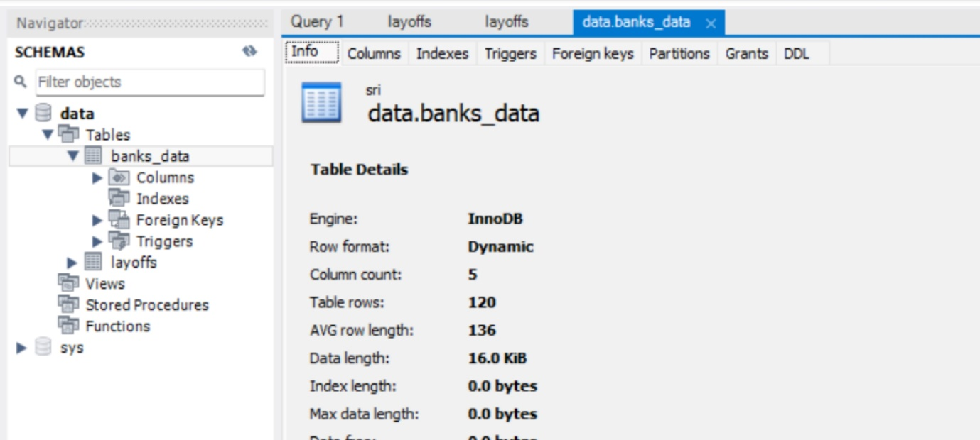

1. Top banks according rank and assets
2. Top banks according to country based on total assets